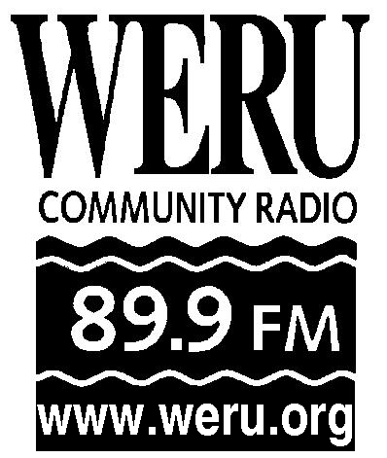
P.O. Box 170
1186 Acadia Highway
East Orland, ME 04431
(207) 469-6600
info@weru.org

Organizing an Event
A Guide for WERU Staff and Volunteers

1. Propose your idea for an event to the WERU Development Committee.
- Share your idea with a committee or staff member, or notify the committee that you will attend a meeting to pitch your idea.
- Give a thought-out proposal including suggestions for date, location, potential costs and benefits and potential organizers.
- What are the goals for the event? Fund Raising? Fun raising? Community building? Sharing news, perspectives and information?
- Working with the Development Committee will help identify whether there is event funding in the budget, and it will help create a strategy and plan.

2. Identify core organizers for the event.
- Who will help you organize this event? WERU volunteers? Others? Most events will require a team of people to work on them.
- Will WERU partner with another organization for this event? The General Manager and Underwriting Manager and Development Director can help establish agreements and conditions for partnerships.
- How will organizers communicate and delegate responsibilities?

3. Book the event.
- Where will the event be held? When? Who will perform/present?
-Who is responsible for communicating with venue, performers, presenters, media, etc?

4. Promote the event.
- Create promos to air on WERU. Ask the Program Manager for support in writing and producing on-air promos. See the “Writing an On-Air Promo” document.
- Promote the event online, on weru.org and on the WERU facebook page. The Underwriting Manager and News Director can help post content online.
- Promote the event in WERU’s Salt Air Program Guide, and in the Family Funnies Volunteer Newsletter.
- Flier for the event. Post and email fliers for people to print and distribute themselves.
-Do direct outreach (phone calls, emails) to individuals and organizations that may be interested in the event.
- Write a press release for the event. See the “Writing a Press Release” document. Directly call news organizations that you hope will cover the event and confirm they received your press release.
-Cross promote with performers, presenters and venue.

5. Event Set Up.
- Plan ahead. Make a list of what needs to be brought and set up (food, equipment, WERU merchandise, promotional material, etc.)
- Who is responsible for what?

6. Hosting and follow-up.
- Take every opportunity to talk about the WERU community and mission statement.
-One person must be responsible for the money made at the event and giving it to the Finance Manager at the station.
- Return all supplies and equipment to the station neatly and more organized than you found it.
- Who is responsible for what?
- Write a report, description and check list for the event if it might be duplicated in the future.

